**Lesson 6: K-means Clustering un supervised learning algorithm.**

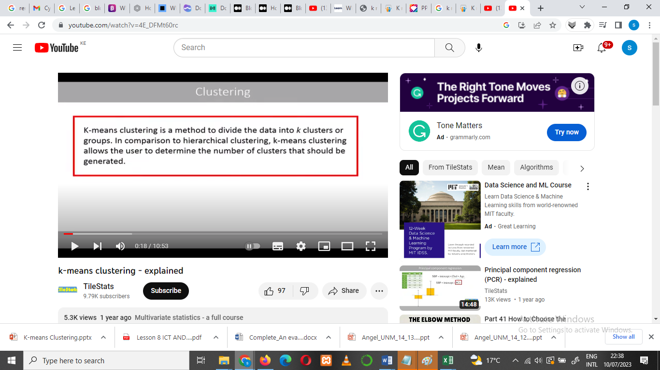

* we are interested in finding out commonalities among our data observations.
  + One way to determine that commonality or similarity is through a measure of distance among the data points. The shorter the distance, the more similar the observations are.
  + **There are different ways in which we can measure that distance** and *one that is very familiar to a lot of people is the Euclidean distance.*
  + 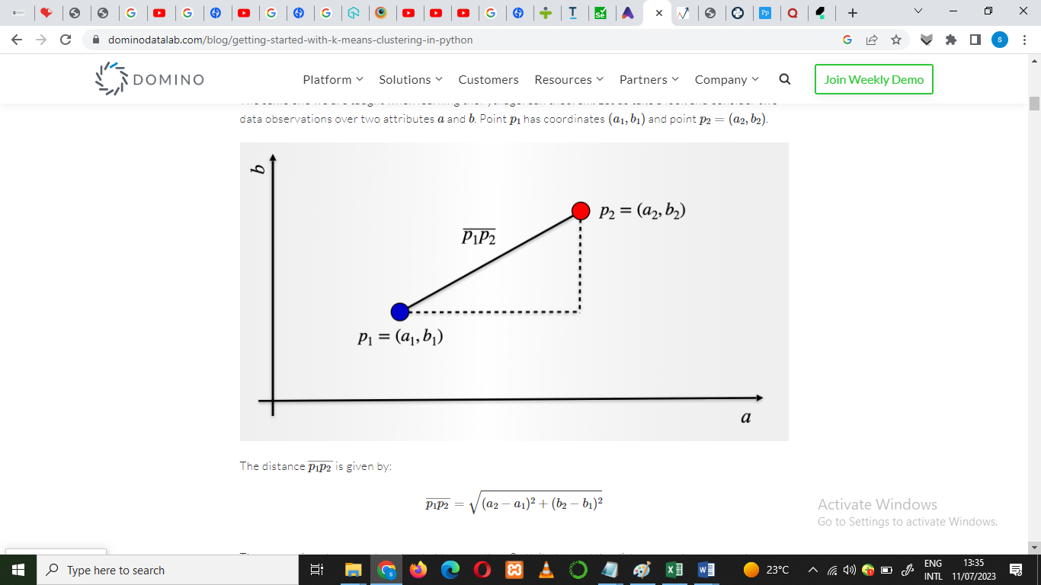





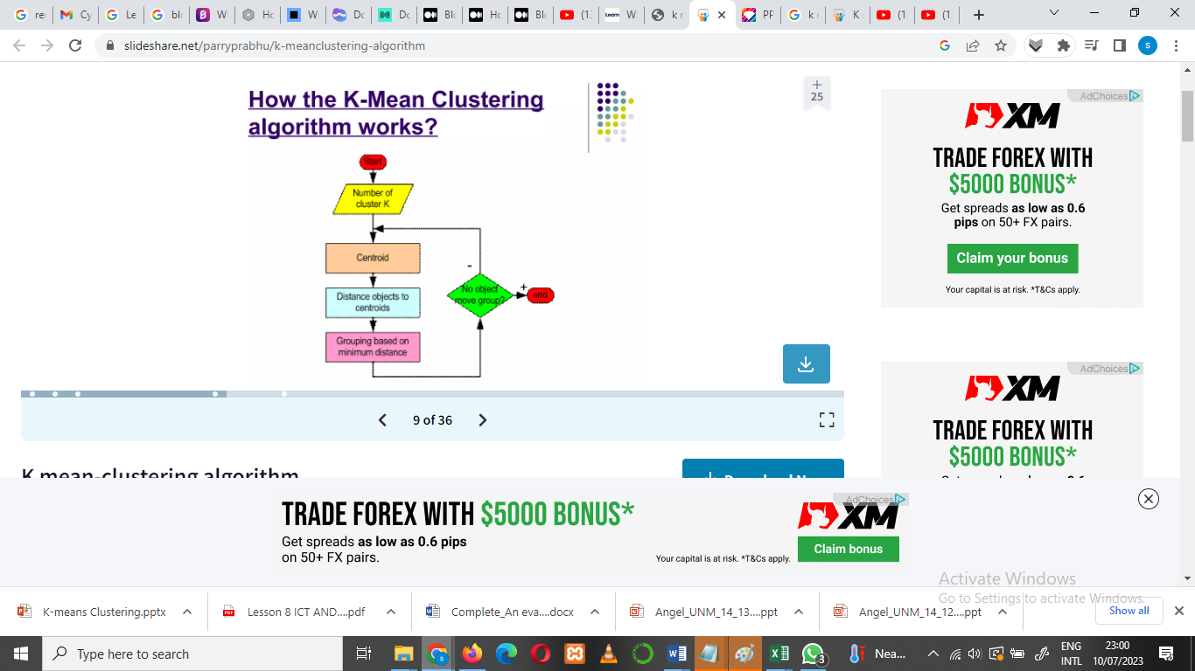

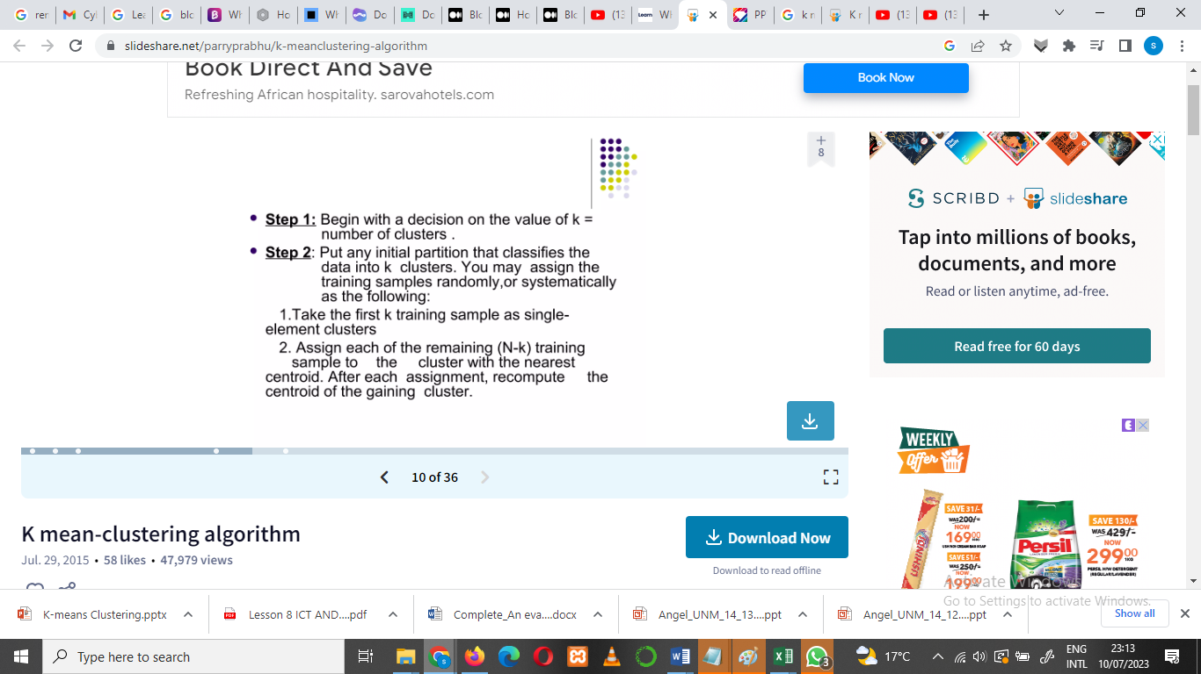

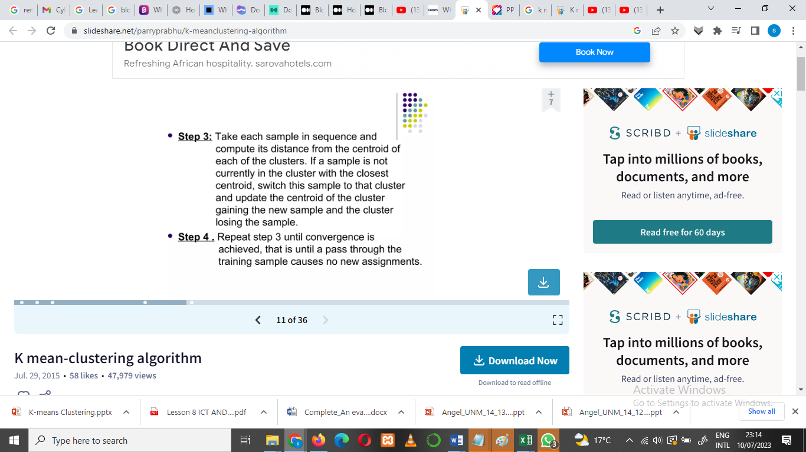

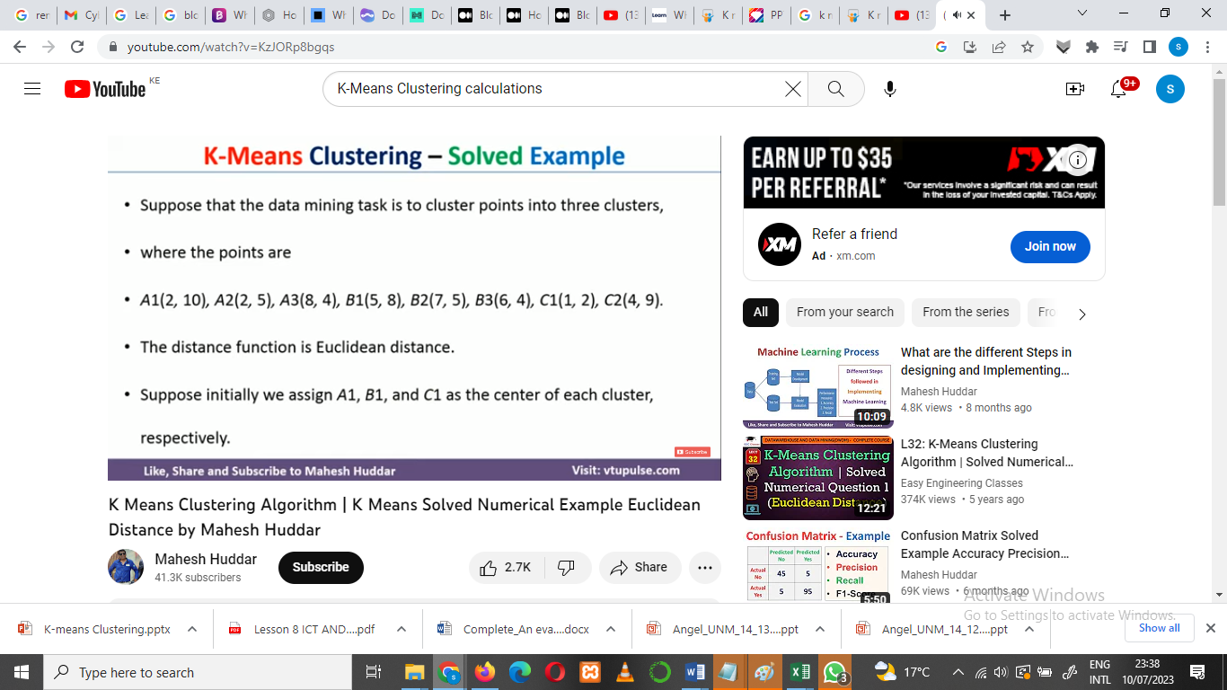

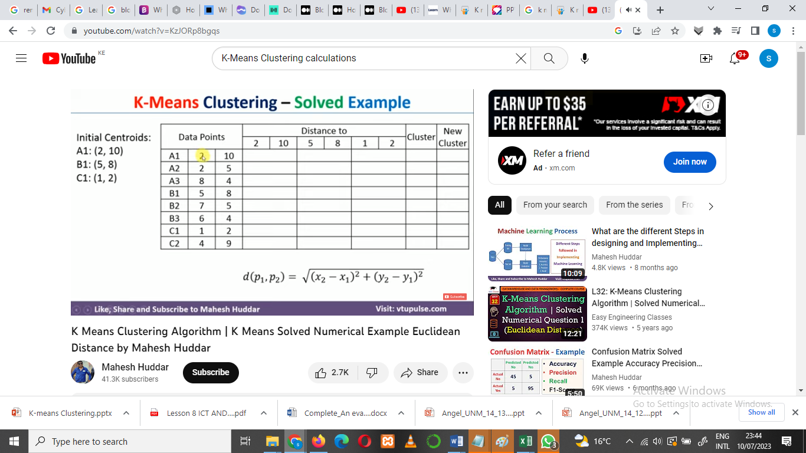

* To calculate the distance of the new cluster we have to use the Euclidean Distance
* Euclidean distance is the shortest path between source and destination which is a straight line.
  + such as finding the nearest hospital for an emergency helicopter flight

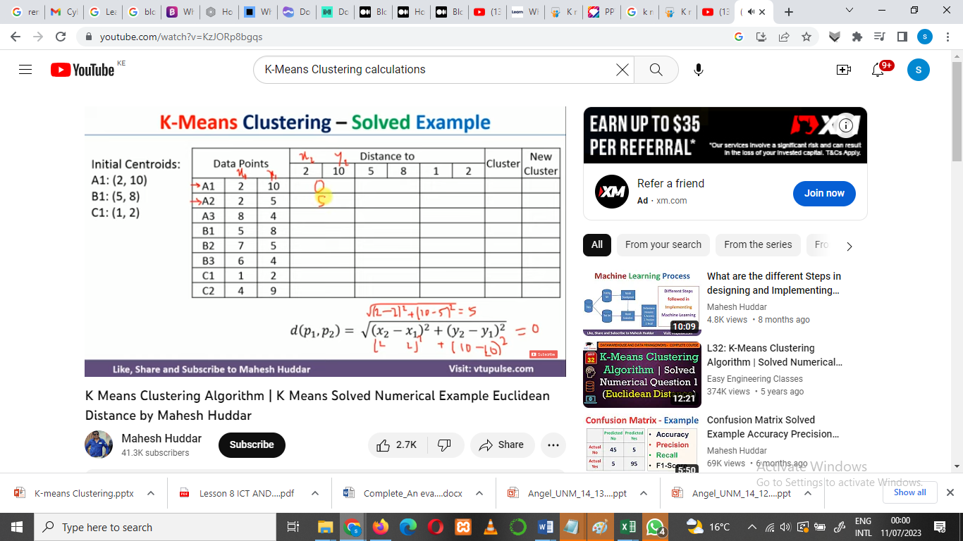

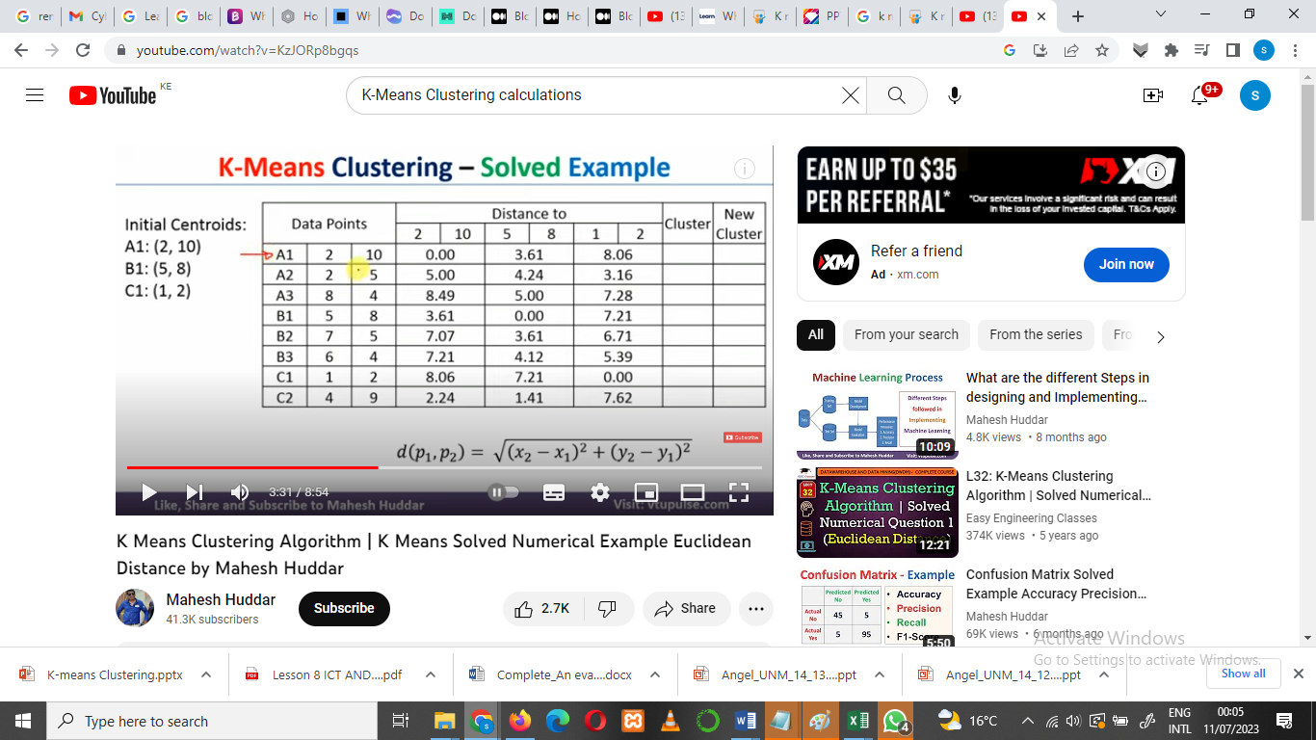

Once the centroids calculations are through ..this is how the distance points should look

Fig Above.

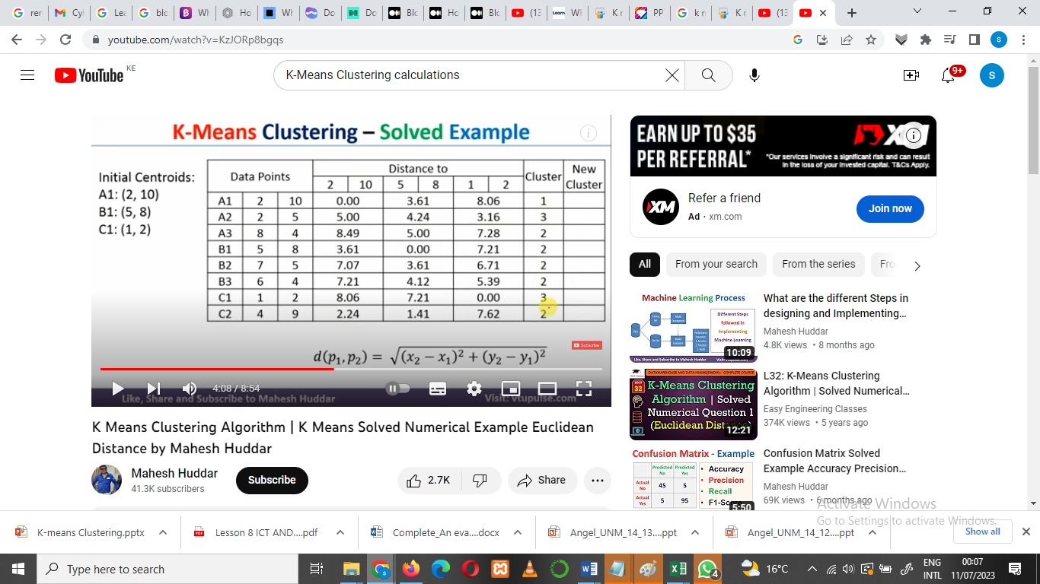

Next step:

Iterate by calculating the new centroid

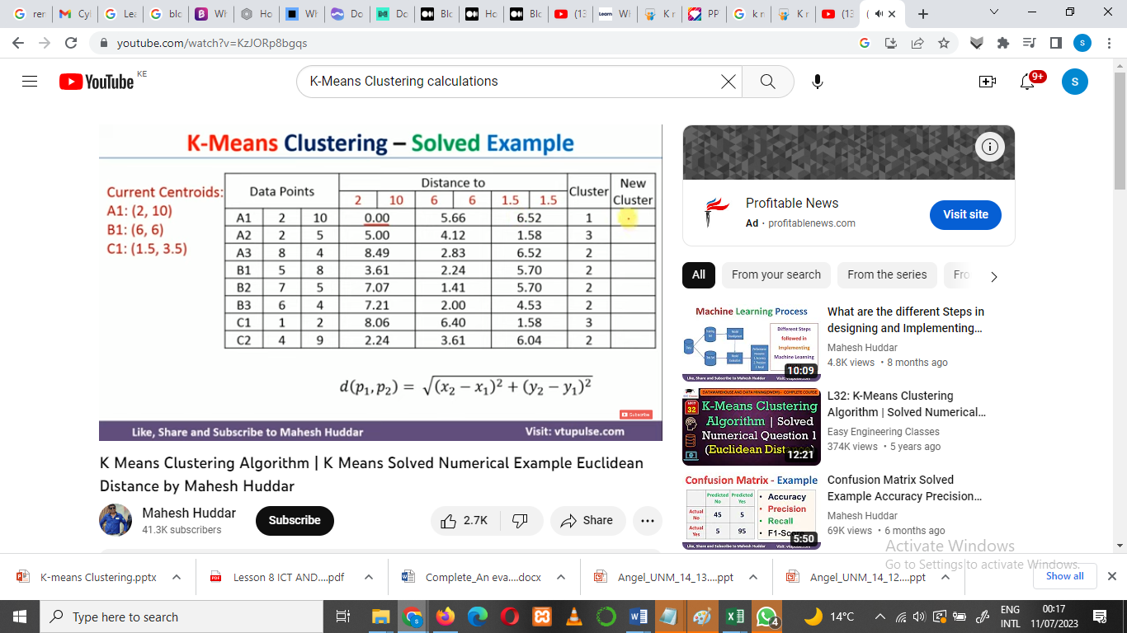

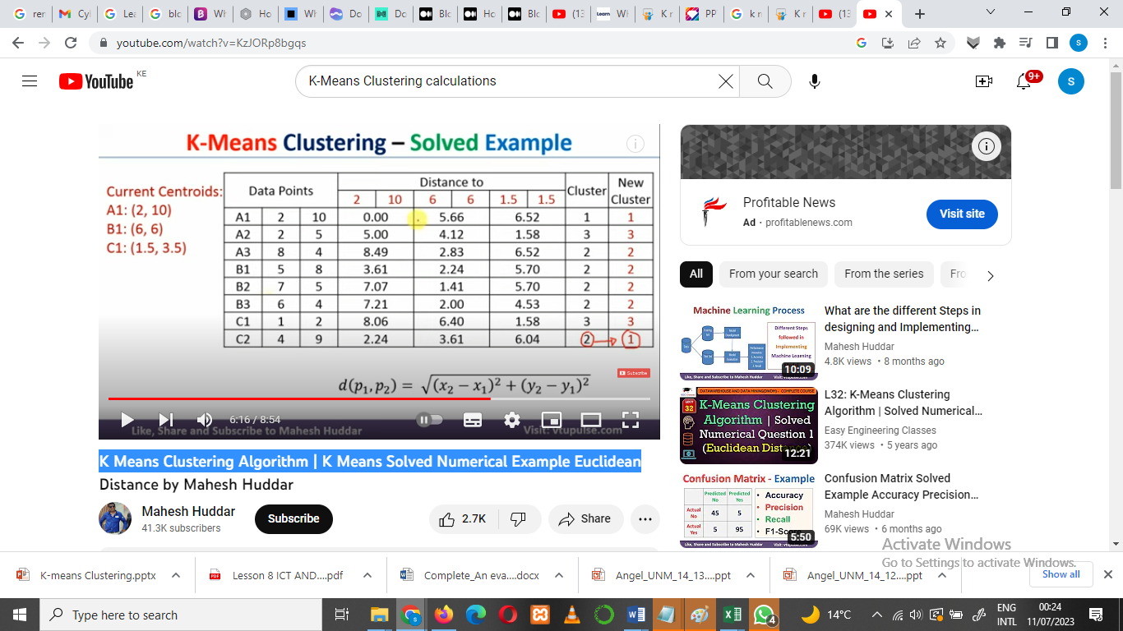

We need to iterate again until we get the original and the new cluster points same grouping.

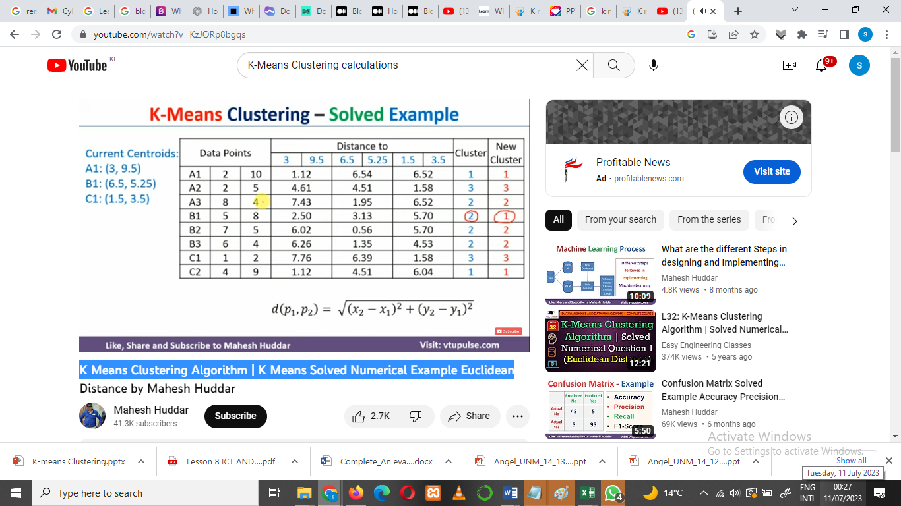

Final centroid

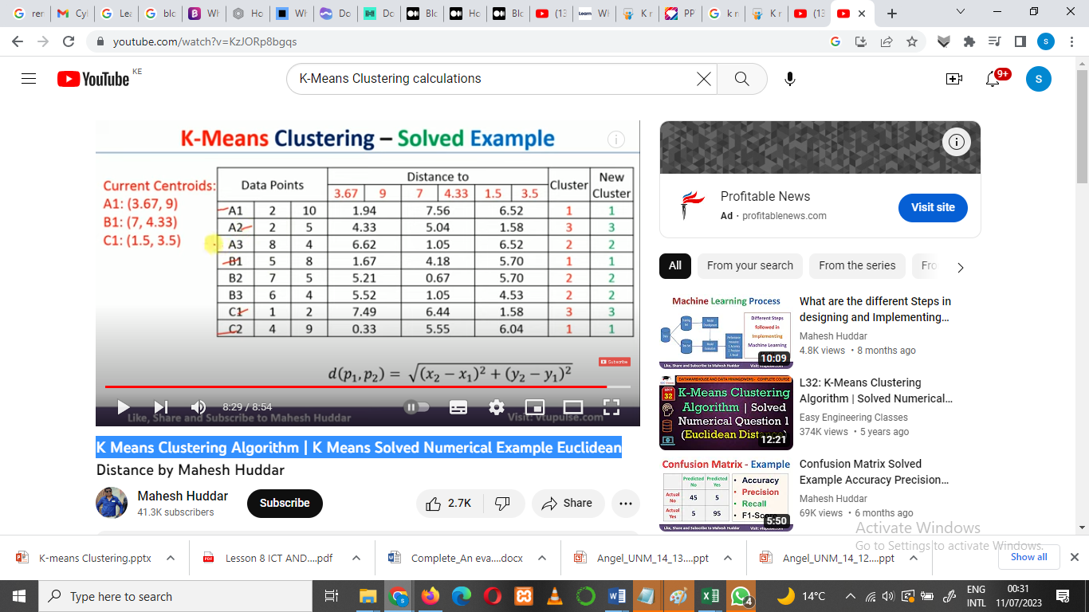

Reference material Video link

**K Means Clustering Algorithm | K Means Solved Numerical Example Euclidean**

<https://www.youtube.com/watch?v=KzJORp8bgqs>

